Name ___________________________________ Period ____
Geography and Continents Test Review Sheet

Directions- Alone, or with a partner, please define or explain each term you will need to know for the test.
1. hemisphere _________________________________________________________________
2. political map ________________________________________________________________
3. physical map ________________________________________________________________
4. culture _____________________________________________________________________
5. continent ___________________________________________________________________
6. climate _____________________________________________________________________
7. lines of latitude ______________________________________________________________
8. lines of longitude _____________________________________________________________
9. Equator _____________________________________________________________________
10. Prime Meridian ______________________________________________________________

11. Five Themes of Geography
a. Location:
absolute ______________________________________________________________________
relative ______________________________________________________________________
b. Region _____________________________________________________________________
____________________________________________________________________________________
c. Place:
human characteristics __________________________________________________________________
physical characteristics _________________________________________________________________
d. Movement _________________________________________________________________________
_____________________________________________________________________________________
e. Human/Environment Interaction ________________________________________________________
_____________________________________________________________________________________

You will also be given a map of the world, continents, and oceans.
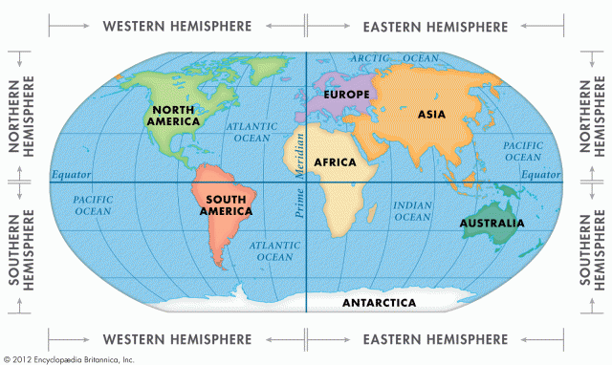

You will be asked about the parts of the world (including important lines of latitude, longitude, and hemispheres) and their locations.
Finally, you will be asked to respond to this question:
In your opinion, which Theme of Geography is most important to understand a Place in the world? Why?
You may plan your response BEFORE the test using a planning paper from the back of the classroom- or one that you make yourself.
However, your plan must be approved by Mr. Davey on the day of the test (or, the day before the test is fine). It can’t be too specific or be a written response.

Here are some ways I can prepare for this test:
1. ________________________________________________________________
2. ________________________________________________________________
3. ________________________________________________________________
4. ________________________________________________________________

This test will be on _________________________________________________________.

